**Q2.** Create a class Voter(voterId, name, age) with parameterized constructor. The parameterized constructor should throw a checked/Unchecked exception if age is less than 18. The message of exception is “invalid age for voter”.

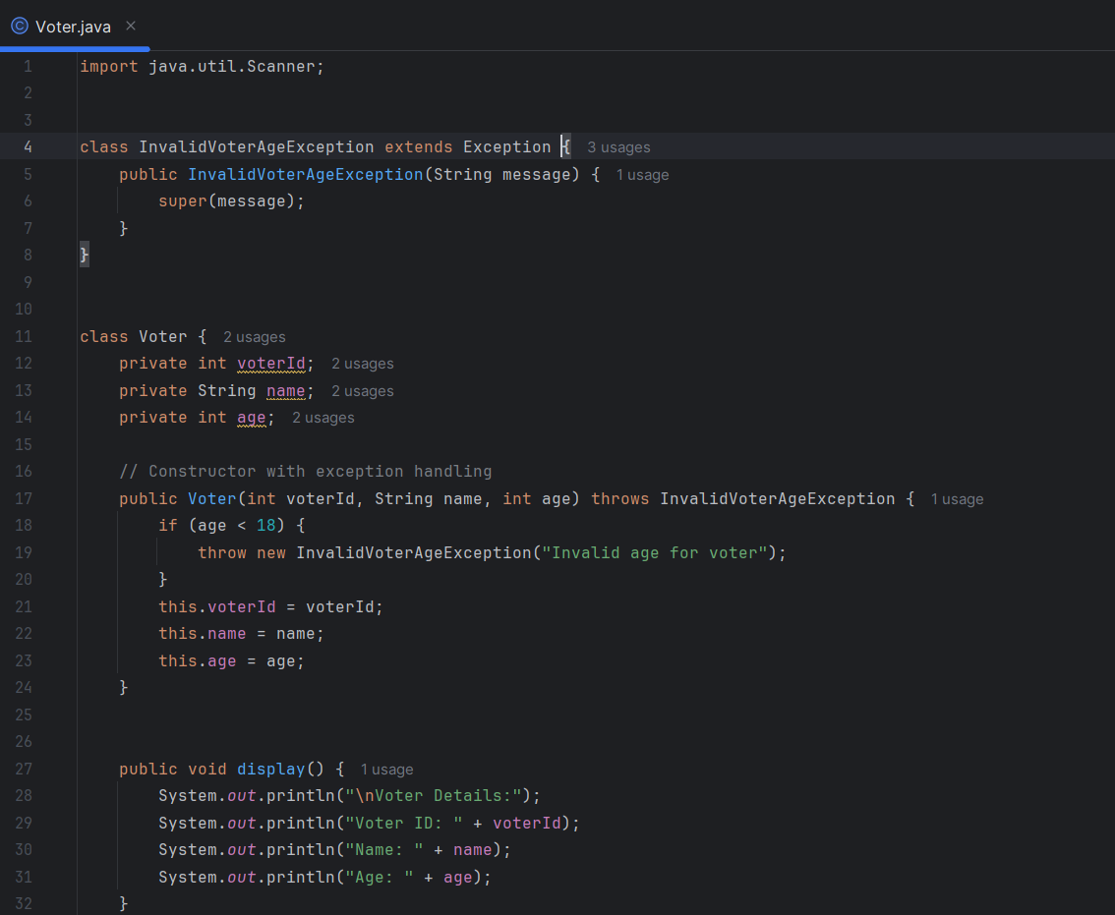

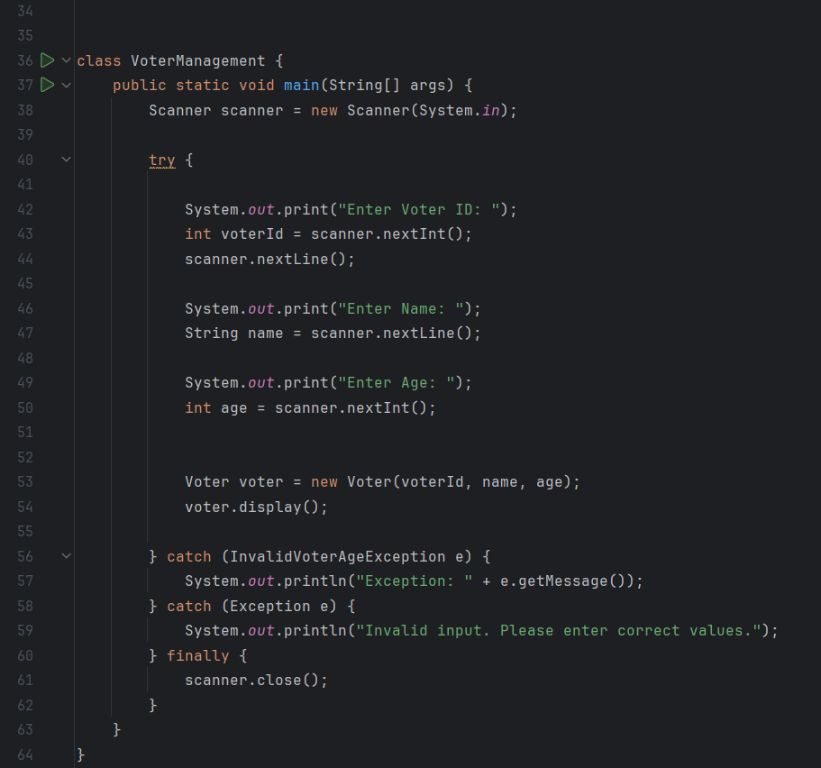

Output;

